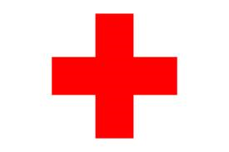IN AN EMERGENCY

 The location of the Assembly Area is:
Answer:

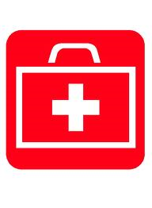 First Aid Kits are located at :
Answer:

 The nearest hospital Accident and Emergency department is:
Answer:
(a map is available of how to get there)

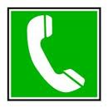The nearest Telephone for use in an emergency is:
Answer:

Guidelines for dealing with an incident / accident

- Stay calm but act swiftly and observe the situation.
- Is there danger of further injury ?
- Listen to what the injured person is saying.
- Alert the first aider who should take appropriate action for minor injuries.
- In the event of an injury requiring specialist treatment, call the emergency services.
- Do not move someone with major injuries. Wait for the emergency medics.
- Deal with the rest of the group and ensure that they are adequately supervised.
- Contact the injured person's partner / parent / carer.
- Complete an incident/accident report form and send this to BOF asap.

Last updated 21st September 2011

