|  |  |  |
| --- | --- | --- |
| OCTAVIAN DROOBERS  The Orienteering Club for Warwickshire & Coventry  Affiliated to British Orienteering  www.octavian-droobers.org/wow  **Warwickshire Orienteering Weekend**  **Midland Championships**  **BENTLEY WOODS**  **At**  **Merevale Hall, Atherstone, Warwickshire**  **On**  **Sunday 26th March 2017 (Mother’s Day)** | Clubmark_logo_2clr_S web | |
| Level A, UK Orienteering League, UK Junior Elite League | |  |

Travel: Atherstone lies on the A5 between its junctions with the M42 and M69 motorways. All but local competitors are likely to approach Atherstone along the A5. Parking is in the town centre which should only be approached from the eastern end (Hinckley, M69) of the Atherstone bypass. If travelling by rail, the station is nearer to the event than all car parks and passed on the walk to the arena. The bus station is located at the western end of town centre, adjacent to some car parks and nearer to the arena than most parking.

Car Parking: Cars will be parked in a number of town centre car parks and street parking areas with a walk of up to 1.25km to the arena from the furthest. It is a level walk on town pavements the whole way. Follow signs to the town centre from the eastern end of the Atherstone bypass. You will encounter the first marshal in just under 1km at a spot island at the junction of Woolpack Way. The marshal will direct you ahead along Long Street to enter a traffic flow around the town filling up parking areas as you go. First arrivals will be nearer the arena. From all parking areas, the train station and bus station, make your way to Long St (the old A5 through the town) and walk in a westerly direction. Near the station, take the left-hand fork along the lane (Old Watling Street) passing under the railway bridge (note: the left fork is the old A5 and continues in the same direction as Long St). Continue over the canal bridge and the gate to Merevale Hall is 150m on the left.

Please take care when walking from your vehicle through Atherstone to the Arena at Merevale Hall. Under 16’s must be accompanied by an adult

Coaches, Mini buses and club tent drop off: There is limited space in Merevale Road for coaches, mini-buses and high camper vans – please contact [keith.willdig@btconnect.com](mailto:keith.willdig@btconnect.com). This is also the club tent drop off point and is adjacent to the hall gates. Merevale Lane can only be accessed from the western end of the Atherstone bypass when travelling in a westerly direction. After dropping your tent, return to the bypass and follow to the roundabout at the western end in another 200m. Go around the island and travel back 2km to the eastern end and follow the above car parking instructions.

Merevale Hall Drive: The Verge to the Drive is precious – please walk on the carriageway, unless to avoid a vehicle.

Arena: Located in the grounds of Merevale Hall. Follow the taped route from about 200m beyond the gatehouses. Please respect the privacy of the gatehouse tenants as you enter the grounds. There is plenty of room for club tents in the arena with start and finish close by for the main event.

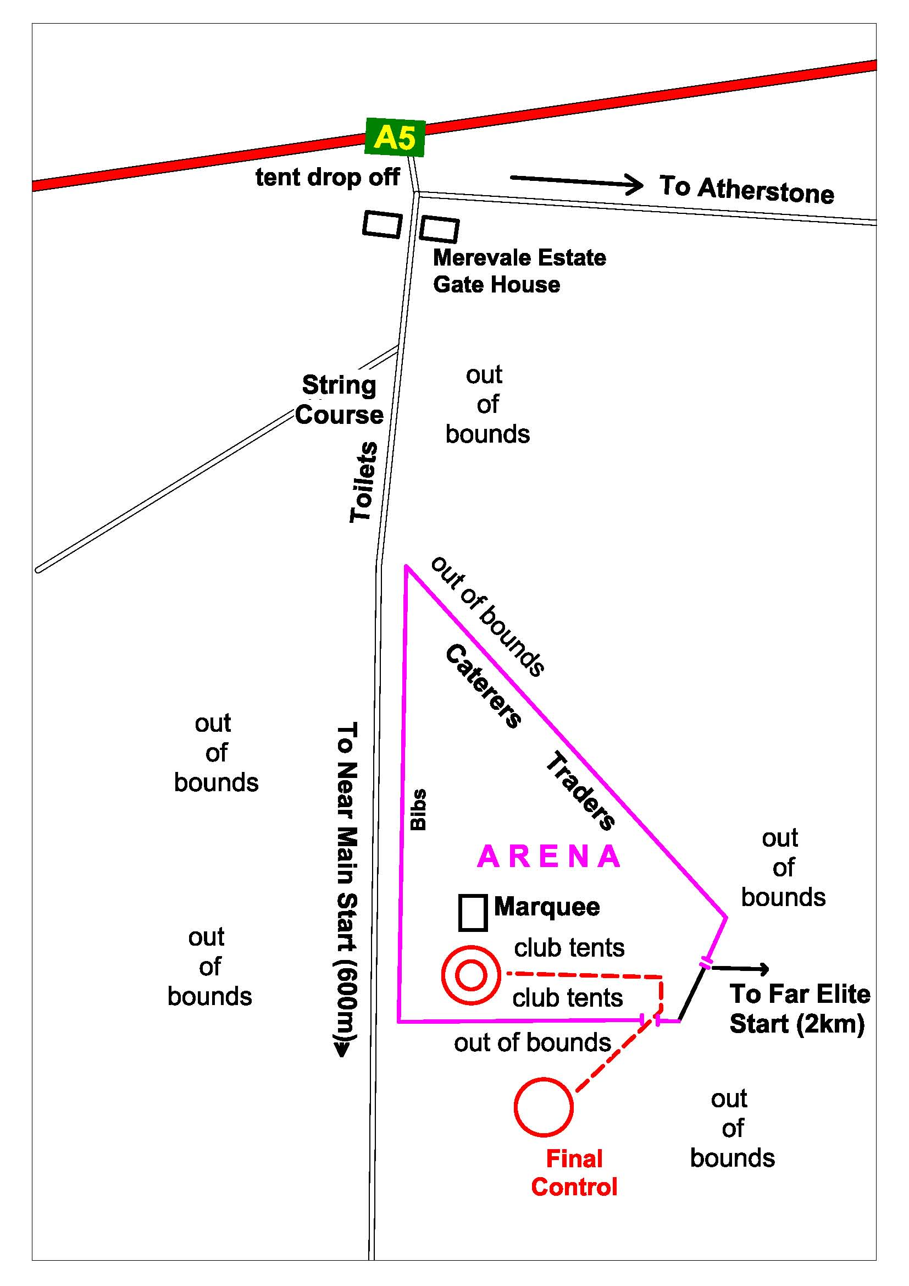

Remember to put your Clocks/watches forward to British Summer Time on Saturday night !

Times: Registration / Enquiries from 9:00

Start times from 10.30 to 13:00

Courses close at 15:00

Entries: Pre Entry on Fabian 4 ([www.fabian4.co.uk](http://www.fabian4.co.uk)) required for all age-class courses until midnight on Sunday 19th March 2017.

Entry on the day only, for White, Yellow, Orange and Light Green Courses.

Entry Fees: Adults £ 14.00

Juniors £ 6.00

EMITag Included in entry fee

**Electronic punching:** The EMIT contactless electronic punching system will be used. EMITags will be issued at the Start. **Using your own EMITag or brikke will not be on option**.

It is the competitor’s responsibility to ensure that the EMITag has registered at each control, start and finish.

A demonstration EMIT control and EMITag will be available in the Arena.

Terrain: An undulating area of woodland consisting of coniferous plantations and areas of fine mature deciduous trees. Be warned that pheasants will be lurking in the undergrowth - they fly out unexpectedly.

Junior Courses pass over a grass dam between a lake and the outflow wall - parents / guardians are asked to make juniors on course 18 aware that they should closely follow the tapes when passing through this short section of their course.

Course Details:

|  |  |  |  |  |  |  |
| --- | --- | --- | --- | --- | --- | --- |
| Course No | Classes | Course length | Controls | Start | Scale | Size |
| 1A | M21E, M20E, M18E – middle distance | 6.4km + 205m | 24 | Far | 1:10,000 | 330 x 270mm |
| 1B | W21E, W20E, W18E – middle distance | 4.8km + 180m | 19 | Far | 1:10,000 | 330 x 270mm |
| 2 | M35L, M40L, M21L | 11.5km + 360m | 26 | Near | 1:15,000 | RA4 |
| 3 | M45L, M50L | 9.9km + 360m | 25 | Near | 1:10,000 | A3 |
| 4 | M55L, M18L, M20L, W21L, M21S | 9.5km + 260m | 22 | Near | 1:10,000 | A3 |
| 5 | M60L , M16A | 8.3km + 215m | 19 | Near | 1:10,000 | A3 |
| 6 | W35L, W40L, M35S, M40S, Blue | 7.7km + 220m | 18 | Near | 1:15,000 | RA4 |
| 7 | M65L, M45S, M21V, W45L, W50L | 6.8km + 240m | 21 | Near | 1:10,000 | A3 |
| 8 | M70L, M50S, M55S, M20S, M18S, W55L, W21S, W20L, W18L, W16A | 6.2km + 200m | 18 | Near | 1:10,000 | A3 |
| 9 | M75L, M60S, W60L,W35S, Green | 5.8km + 150m | 19 | Near | 1:10,000 | A3 |
| 10 | M65S, W65L, W70L, W40S, W45S, W50S | 5.1km + 175m | 15 | Near | 1:10,000 | A3 |
| 11 | M80, M70S, W75, W20S, W18S,W21V, W55S, W60S | 4.2km + 135m | 15 | Near | 1:10,000 | A3 |
| 12 | M85, M90, M75S, W80,W65S,W70S | 3.2km + 120m | 12 | Near | 1:10,000 | RA4 |
| 13 | W85, W90 | 2.8km + 60m | 11 | Near | 1:10,000 | RA4 |
| 14 | M14A, M16B | 5.8km + 210m | 17 | Near | 1:10,000 | A3 |
| 15 | W14A, W16B, Light Green | 4.1km + 130m | 14 | Near | 1:10,000 | A3 |
| 16 | M12A, M14B,W12A, W14B, Orange | 3.7km + 100m | 11 | Near | 1:10,000 | RA4 |
| 17 | M10A, M12B, W10A,W12B, Yellow | 2.8km + 75m | 12 | Near | 1:10,000 | RA4 |
| 18 | M10B, W10B, White | 1.6 km + 35m | 11 | Near | 1:10,000 | RA4 |
| String | String course |  | 10 | Close to arena | 1:2500 |  |

Juniors & String: A String Course will be available at Merevale Hall close to the Arena.

**Map:** By Bruce Bryant surveyed in 2016 with selective updates in 2017 – map scale and size as shown above – with 5 metre contours for all courses on waterproof paper.

Special map symbols are shown on an extract from the legend on the next page. One symbol of note is the green dot which is used as normal for a thicket, however in one area near the finish there are distinctive trees of about 2 metre diameter trunk, covered with “bushy vegetation” each sitting in small areas of white wood and surrounded by walk forest. We experimented with different symbols for these trees and how to map the walk forest. See below for samples and the final decision highlighted in purple: Green dots for the trees with Walk undergrowth for the thicker forest.

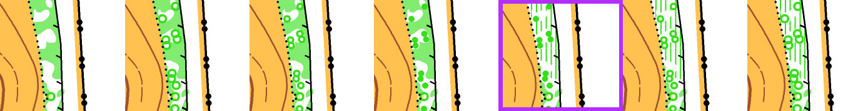

**Special Map Symbols:**

**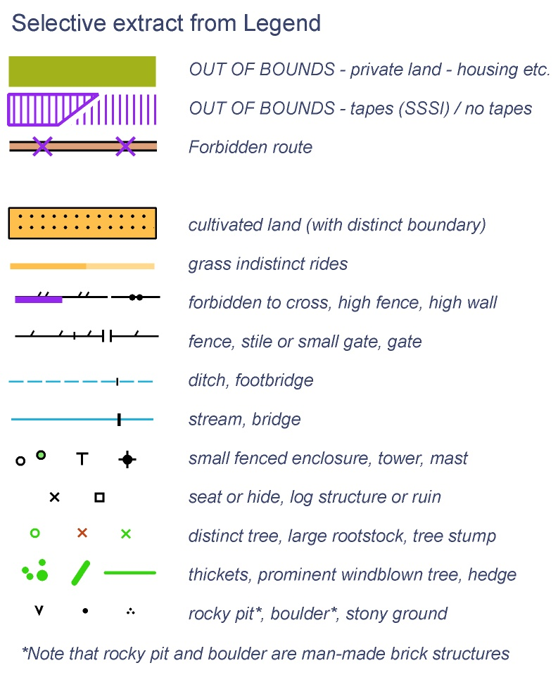**

Control Descriptions: Control descriptions will be printed on the map. Loose control descriptions will be available in the start lanes.

Whistle: It is compulsory to carry a whistle at West Midlands events.

Race Numbers: Bibs will be used for both days competitions. Bibs should be collected from a line along the fence at the west side of the Arena. Bibs will be in alphabetical order.

Those people who ran the Rugby Urban on Saturday will use the same bib.

Trophy Return: Please return trophies to Hilary Simpson at the marquee.

EMITag Issue: Will be at the Start

The Near Main Start: 600 metres from the Arena along a gently rising surfaced estate road

Call up is at your start time minus 4 minutes for EMITag issue and check. Loose control descriptions will be available at -3 minutes. Blank maps displayed at -2 minutes. Young Junior course 7 maps will be available at the pre-start. It will be a run through / contactless start. It is the competitors’ responsibility to ensure that their EMITag registers (flashing light) at the start and at all subsequent controls.

The Far Elite Start: 1.82 km + 40m climb from the Arena – a map will be available as you leave the Arena - an undulating off-road walk through the Estate to the Coleshill Road then along the footway to cross the road at the Marshal point. Take great care crossing the Coleshill Road to the Start and from the Finish.

Road Crossing during competition:

Note that courses 2 to 11, 14 and 15 cross and re-cross Coleshill Road. Marshals will be present. Take great care crossing the road.

There will be a one minute time out for each crossing of the road.

The Near Main Finish: is in the Arena

The Far Elite Finish: is close to the Elite Start. Route back to the Arena is reverse of the route to the Elite Start. Take great care crossing the Coleshill Road.

Compulsory Safety Check: There will be an electronic EMITag safety check at -4 minutes. This will record all starters and will be used at download to ensure that all competitors are accounted for. IT IS THEREFORE ESSENTIAL THAT ALL COMPETITORS WHO START REPORT TO DOWNLOAD EVEN IF THEY DO NOT COMPLETE THEIR COURSE.

Safety and First Aid: All competitors take part at their own risk. They are responsible for their own safety and that of fellow competitors and members of the public. First Aid will be provided in the Arena at the Finish. Emergencies must be directed to A & E. The nearest A & E Hospital is George Eliott Hospital, Nuneaton, CV10 7DJ, tel: 02476 351351 and is 8 miles from the event.

Child Welfare Policy: In line with the recommendation in the British Orienteering Child Welfare Policy and Procedures, the promoters of this event request that any person wishing to engage in any video, zoom or close range photography should register their details with staff before carrying out any such photography. The event organisers reserve the right to decline entry to any person unable to meet or abide by the organiser’s conditions.

Insurance: British Orienteering members will be covered by British Orienteering Public Liability Insurance. All other competitors will be covered by that public liability insurance for a maximum of three British Orienteering registered events. Joining Octavian Droobers includes British Orienteering membership

Facilities: Toilets are available near the arena. Traders will be present. The town centre parking facilitates easy access to shops, cafes and pubs after your run.

Dogs: Dogs are allowed in the Arena only – on a lead

Traders: UltraSport; CompassPoint

Caterers: Podium Catering; Bluebell Pizza

**Winner’s Trophies:** There will be a ceremony to present the new 2017 Midland Champions with their trophies, hopefully starting at 14:30.

**Complaints and protests:** If anyone has a complaint about the event they should make it to the Organiser. If they are not satisfied with the Organiser’s decision they can make a protest in writing using the form available from the Organiser or from Enquiries. A jury will be on standby.

Acknowledgements: We are grateful to Rod Duggleby and Celia Jones from the Merevale Estate for their hospitality in staging this event. We also wish to thank Lloyds Chemist and the Atherstone Medical Practice for use of their parking together with North Warwickshire District Council and Atherstone Town Council for welcoming us so readily in their town.

Organiser: Bob Brandon – email [bob.brandon42@gmail.com](mailto:bob.brandon42@gmail.com) (preferred)

Mobile 07943 501 139

Planner: Anne Straube

Controller: Chris Burden, Airienteers

More info: Occasionally circumstances may force late changes. Please check on the club website [www.octavian-droobers.org/wow](http://www.octavian-droobers.org/wow) a few days before the event for the final detail